DIGITAL LOGIC DESIGN PRACTICAL
SESSION 3: HALF ADDER AND FULL ADDER

AIM
To build the Half Adder and Full Adder chips in Nand2Tetris HDL, understand their sum and carry generation, trace carry propagation for a sample input, and verify the outputs using the Nand2Tetris Hardware Simulator.

HALF ADDER
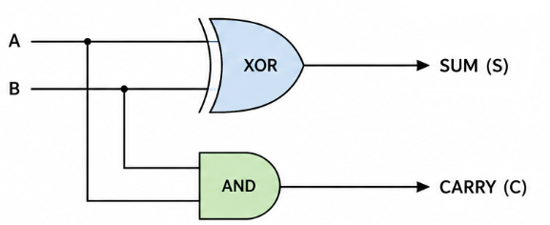

Boolean Expressions
Sum = A ⊕ B
Carry = A · B

Truth Table
A | B | Sum | Carry
0 | 0 | 0 | 0
0 | 1 | 1 | 0
1 | 0 | 1 | 0
1 | 1 | 0 | 1

HDL CODE
HalfAdder
CHIP HalfAdder {
IN a, b; // 1-bit inputs
OUT sum, // Right bit of a + b
carry; // Left bit of a + b
PARTS:
Xor(a=a, b=b, out=sum);
And(a=a, b=b, out=carry);
}

SIMULATION OUTPUT
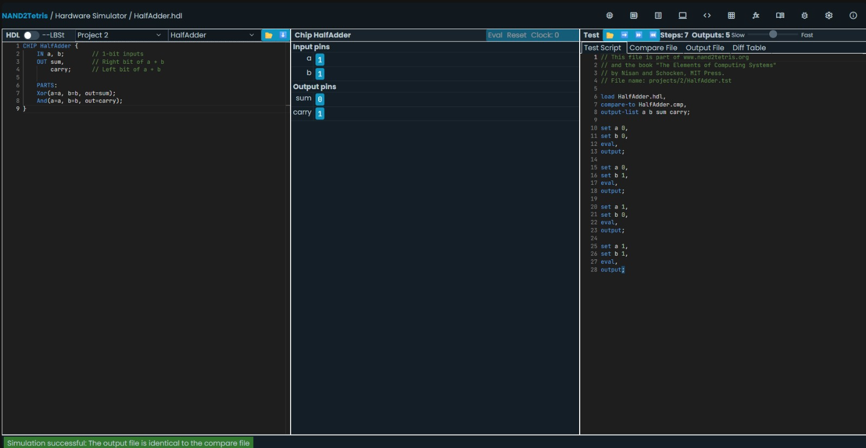
Figure 1: HalfAdder HDL implementation and successful Hardware Simulator output.

FULL ADDER
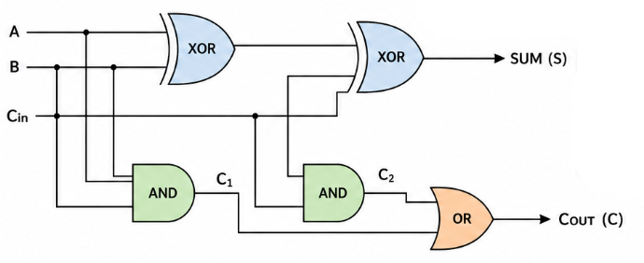

Boolean Expressions
Sum = A ⊕ B ⊕ C
Carry = AB + AC + BC

Truth Table
A | B | C | Sum | Carry
0 | 0 | 0 | 0 | 0
0 | 0 | 1 | 1 | 0
0 | 1 | 0 | 1 | 0
0 | 1 | 1 | 0 | 1
1 | 0 | 0 | 1 | 0
1 | 0 | 1 | 0 | 1
1 | 1 | 0 | 0 | 1
1 | 1 | 1 | 1 | 1

HDL CODE
FullAdder
CHIP FullAdder {
IN a, b, c;
OUT sum, carry;
PARTS:
Xor(a=a, b=b, out=ab);
Xor(a=ab, b=c, out=sum);
And(a=a, b=b, out=c1);
And(a=a, b=c, out=c2);
And(a=b, b=c, out=c3);
Or(a=c1, b=c2, out=c12);
Or(a=c12, b=c3, out=carry);
}

CARRY PROPAGATION — SAMPLE INPUT
Sample input: A = 1, B = 1, C = 0
Stage | Operation | Output
1 | A ⊕ B | 1 ⊕ 1 = 0 → ab = 0
2 | ab ⊕ C | 0 ⊕ 0 = 0 → Sum = 0
3 | A · B | 1 · 1 = 1 → c1 = 1
4 | A · C | 1 · 0 = 0 → c2 = 0
5 | B · C | 1 · 0 = 0 → c3 = 0
6 | c1 + c2 | 1 + 0 = 1 → c12 = 1
7 | c12 + c3 | 1 + 0 = 1 → Carry = 1

Final output: Sum = 0, Carry = 1. The carry generated by A and B propagates through c1 → c12 → carry.

SIMULATION OUTPUT
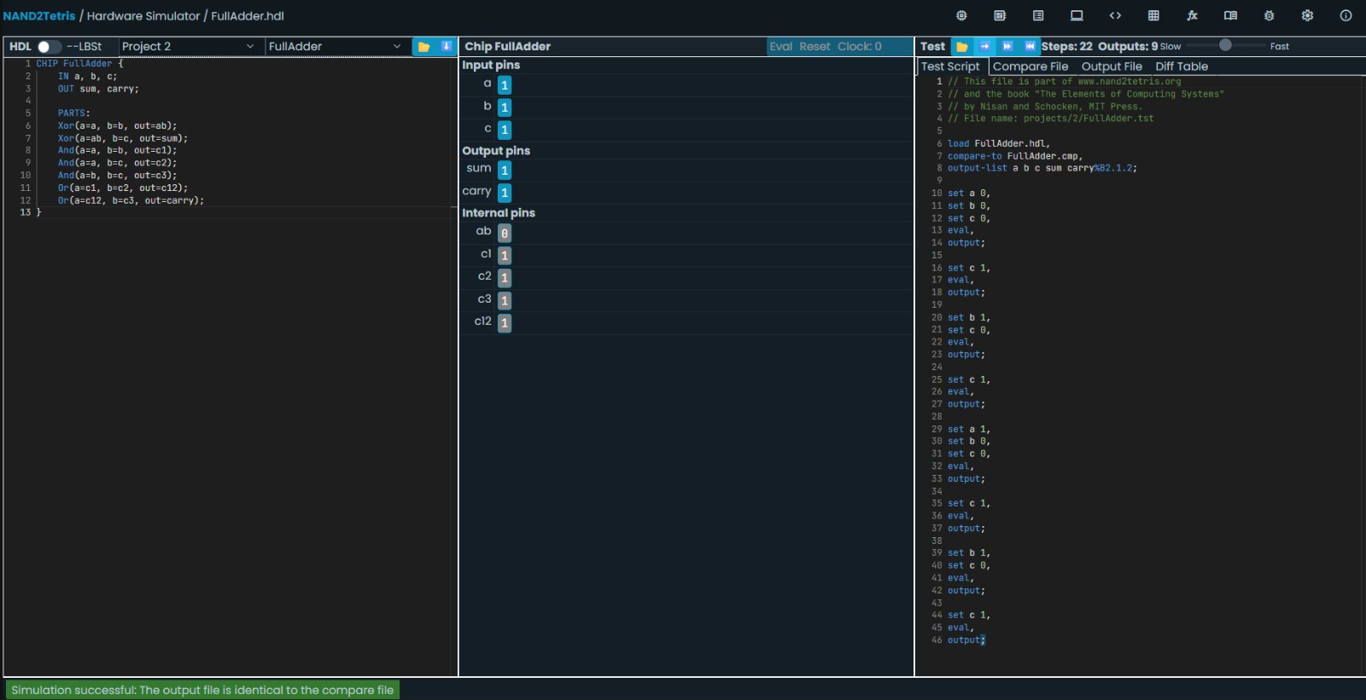
Figure 2: FullAdder HDL implementation and successful Hardware Simulator output.

RESULT
The Half Adder and Full Adder chips were implemented successfully using Nand2Tetris HDL. The Half Adder generates the sum and carry for two 1-bit inputs, while the Full Adder incorporates an additional carry input and produces the corresponding sum and carry output. Carry propagation was traced for a sample input, and both circuits were successfully verified using the Nand2Tetris Hardware Simulator.

